3.2 – User Interface Subsystem Interface
User Interface subsystem provides graphical system components for our project. In addition, it also manages transition between panels which are constructed for different selections in main frame screens. The reference of User Interface Subsystem to other subsystems is provided by mainFrame class which is considered as an interface.
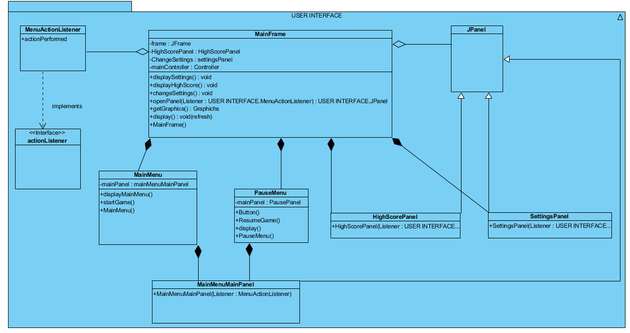

Figure-1( User Interface Subsystem )

MainFrame Class
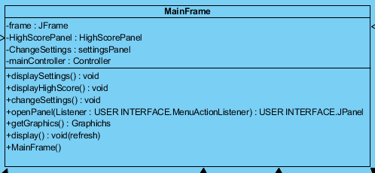
Attributes
private Jframe frame: This is the frame which provides display all visual context for us.
private HighScorePanel: This panel shows the highest score of the user.
private ChangeSettings settingsPanel: This Panel or Jpanel is used in graphical user interface to show to user setting or change setting menu on the screen.
- This property is constructed by ChangeSettings class with its components like buttons, labels etc…
private mainController controller: This mainController type property of MainFrame class provides reference to GameManagement subsystem, when Play Game selection is received from graphical user interface.
- This property is constructed by mainController class with its components like buttons, labels etc…
Constructor
mainFrame(): constructs a frame that our panels can fit into it properly.
Methods
public void displaySettings(): It represents change settings panel for the main frame.
public void displayHighScore(): It provides the high score display and user can see the high score in this screen.
public void changeSettings(): It holds together all components which provides changing settings for the user.
public Jpanel openPanel(): It provides the opening new panel for us. It provides panel to the main frame as a basic operation.
public Graphics getGraphichs(): returns a graphics context for drawing to an off-screen image.
public void display(): It initializes the game and entity objects which are coming from the controller are displayed by this method.

Main Menu Class
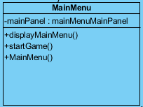
Attributes
private mainMenuPanel mainPanel: this is the main panel that main menu to be displayed in terms of graphical user interface

Constructors
public MainMenu(): constructs a main menu by modifying mainMenuPanel.

Methods
public void displayMainMenu(): this method puts the mainMenuPanel into the MainFrame in order represent it on the screen.

public void startGame(): starts the game logic and loads the game components.

- Following methods are inherited from parent MainFrame class
  - displayHighScore()
  - displaySettings()
  - openPanel (MenuActionListener e, Jpanel p)

Pause Menu Class
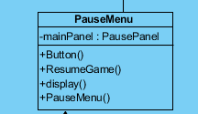

Attributes
private PausePanel mainPanel: this is the pause panel that pause menu to be displayed in terms of graphical user interface

Constructor

public PauseMenu(): constructs a main menu by modifying PausePanel.

Methods

public void display (): this method puts the PausePanel into the MainFrame in order represent it on the screen.

public void ResumeGame(): in the state of stopping all objects, this methods starts stopped objects moving according to game logic.

- Following methods are inherited from parent MainFrame class
  - displayHighScore()
  - displaySettings()
  - openPanel (MenuActionListener e, Jpanel p)

MenuActionListener class
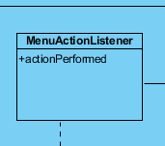

public void actionPerformed(ActionEvent e): overrides actionPerformed() method from ActionListener interface.

- HighScorePanel, ChangeSettingsPanel, MainPanel classes are not detailly expained, they instantiate requested panels and ActionListener places them on the main frame.

private mainPanel mainMenuPanel:

